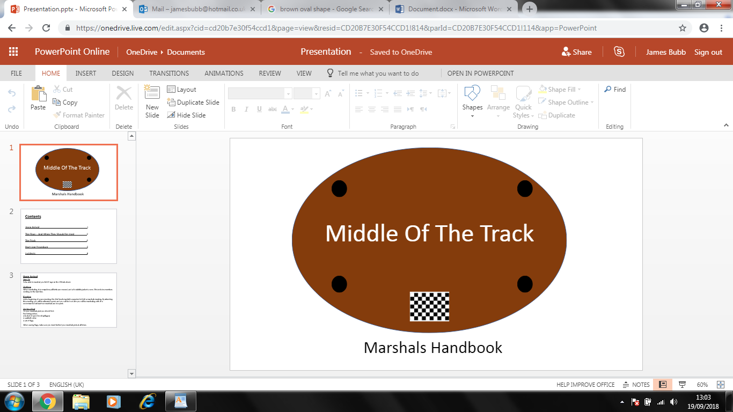

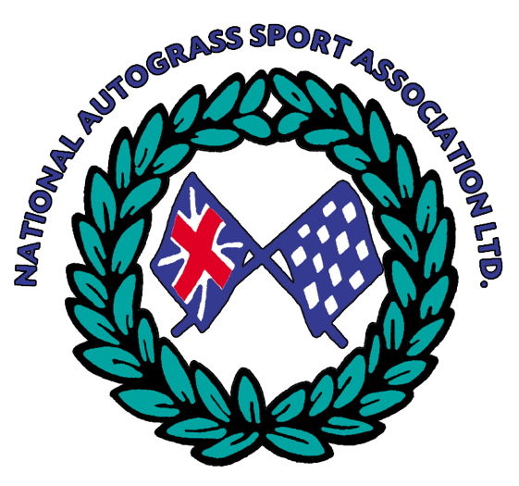

**Contents**

Upon Arrival 1

The Flags – And When They Should Be Used 2

The Track 3

Start Line Procedure 4

Incidents 5

**Upon Arrival**

Sign On

To be able to marshal, you MUST sign on the Officials sheet.

Clothing

When marshalling, it is compulsory all limbs are covered, and a high visibility jacket is worn. This includes members working on the start line and breakdowns. Refer to the rule book for more information Page 21. From 2024, two piece workwear or overalls are permitted provided they meet EN ISO 20471 (General Workwear such as “oranges”)

Meeting

At the beginning of a race meeting, the Chief Track Marshal is expected to hold a marshals meeting. By attending this meeting, you will be allocated a post, and you will find out who you will be marshalling with. It is recommended at least two marshals are on a post, maximum is now three from 2024.

There is a standard brief that has been created to cover the important information (Appendix 1).

On Your Post

On your marshals post you should find:

Fire Extinguishers

A bucket of sand (for oil spillages)

A seatbelt cutter

A set of flags.

When waving flags, make sure you stand **behind** your marshals post **at all times.**

If any of these items are not present, speak to the Chief Track Marshal / Safety Officer / Chairman before racing starts.

**The Flags – And When They Should Be Used**

**Make sure all flags are not visible to racers whilst not in use to avoid confusion**

Red Flag – Stop Racing / Don’t Start Racing

If there is a rollover or a severe obstruction on track causing danger to drivers, marshals or spectators, then racing should be stopped. Allow time for stationary cars on the racing line to move.

If there is a start line infringement, red flag the race immediately. This includes dangerous driving off the start line, jumpstarts where the driver doesn’t yield, and problems with the start line.

If marshalling on the corner after the finish line, it is advised to put your red flag out once the lead car has taken the chequered flag to avoid a lap of honour.

If you have mistakenly raised your red, keep it up and explain it was a mistake after. If one corner has a red flag up, all red flags should be up.

Yellow Flag – Obstruction on Track

If there is an obstruction on track that is not a danger to anybody, wave your yellow flag. For example, if a track marker has been knocked into the middle of the track, or a car is stationary off the racing line a yellow flag should be waved.

Blue Flag – Mechanical Default

If a vehicle is producing a lot of smoke / steam, has damage to wheels / tyres or has loose car parts / panels issue a blue flag.

Black Flag – Driver is Disqualified

A black flag should be issued on track if a driver: has hit three or more track markers on one corner on the same lap, has caused a race stoppage, drives on the infield at racing speed, hit one or more track markers and gained a position, continuously makes contact with others cars, receives two green flags, takes another car out of a race or a driver races under red flags. A black flag must also be issued in the pits.

Green Flag – Driver Is Docked Two Positions

If a driver hits two track markers issue the green flag on the corner he hit the track markers, uses excessive contact to pass a car, or hits a car numerous times then give a green flag.

Yellow Flag With Black Cross – Last Lap Flag

This should be used when the leading car passes the finish line for the penultimate time.

Chequered Flag – Race Finished

This should be used when the leading car completes the last lap. When the last car has crossed the line put the red flag up. If a car is a lap down but takes the chequered flag, ensure they receive their points and instruct them to exit the track.

White Flag Red Cross / Green Flag White Cross – Ambulance on Track

Should be raised high when there has been a rollover or an ambulance is required on track.

**With the exception of the Ambulance flag, you should wave your flags low to the ground, so the drivers can see them.**

**Stay behind your marshals post at all times when cars are racing.**

**The Track**

Ambulance

Before racing starts make sure the ambulance crew are ready. There must always be ambulance cover whilst a race is underway.

Track Markers

It is advised that a meeting runs with 3 tyres with a cone on the inside tyre. The tyre should be considered part of the track, and the cone is the track marker.

The track markers should be spaced out to guide a smooth curved bend. If the track markers are too close together cars will hit multiple, however if they’re too far apart, drivers will lose the direction of the corner. Similarly, a sharp corner encourages contact, and a smooth corner results in less collisions.

Start line

If the start line is causing drivers to have little or no control over their cars, stop racing and begin track work. Start line marshals should monitor the line to make sure no ruts or craters are affecting the race starts. Maximum of four people plus start person are permitted forward of the holding bays. Any vehicle that completes modifications forward of the holding bays, such as changing tyre pressures, may be excluded from the race.

Track Equipment

It is vital all track equipment (tractors, breakdowns and rollers) and race cars are within the designated area in the middle of the track before the race starts. They should remain here until the race is over. All vehicles on the track must be kept to a minimum.

Once it is safe to do so breakdowns can recover cars. Make sure all drivers keep their helmets on when being towed.

**Start Line Procedure**

The Chief Track Marshal will give track clearance. Make sure there are no vehicles, debris, track markers out of place or obstructions on your corner. When your post is clear raise your yellow flag. When all cars are lined up, have their wheels facing forward and the start line is clear the start line marshal should raise their yellow flag. The Chief Track Marshal will then raise their yellow flag. Once double checking all yellow flags are up and the start line is clear the wind-up marshal can then lower their red and raise the yellow, making sure they remain behind their marshal’s post. The wind-up should be on the first post.

**Incidents**

Rollovers

If a car has rolled over stop the race immediately. One marshal should ensure the other cars stop by waving the red flag, whilst the other runs to the accident with a fire extinguisher. However, the running marshal MUST make sure it is safe to do so. Once at the car, look for dangers for yourself and the driver. Turn off the isolator switch and extinguish fires if necessary by aiming at the base of the fire and away from the driver.

Stand at the front of the car, tell the driver not to move, and to continue looking forwards. Make NO attempt to move the car or the driver until the ambulance crew have given clearance, or under extreme circumstances e.g. if the fire cannot be extinguished.

Stationary Cars

If a car has stopped on the infield, edge of the track or in the barrier, make a visual check. Be sure to get a signal (such as a thumbs up) from the driver to make sure they are okay. If no signal is received red flag the race.

Barriers

If a car has made contact with the Armco, check the Armco and surrounding posts are still in a suitable condition. If there is damage, racing will have to be stopped until the track is repaired.

**Appendices**

Appendix 1 – Marshals Briefing

Before marshalling, make sure you have signed on the officials sheet.

Make sure limbs are covered at all times when on the track and high visibility clothing is worn.

If you raise your red flag by mistake, keep it up and re-run the race. Don’t put it back down as this can cause confusion for drivers.

Prior to a race beginning, raise your yellow flag so the wind-up marshal knows your corner is clear.

When a race is preparing to start or is in progress, stay completely behind your marshal post at all times. This includes when waving flags. Don’t attend a stricken car unless it’s safe to do so.

Make sure the cones are spaced as far away from each other as safe; ensuring the drivers can still see the shape of the corner.

Wave your flag low to the ground so the drivers can see it. If it’s too high, they won’t be able to see above the mesh.

When calling red flags, call it over the radio so all marshals know to wave the red flag.